Assignment 6

Learning Module 4: Topic 4&5

Requirements:
Imagine we are an art supply store that sells brushes, paint, and erasers. To gather order information from our prospective customers we will have to make a web page form to gather the customer's order. The information include:
- Item ordered (brush, paint, or eraser)
- Quantity ordered
- Customer information:
  - First name
  - Last name
  - Phone number
You need to store all the information in your database when a new order is entered. Further, you want to see all the current orders with this new order added.

Before you start your assignment
Create the “Assignment6” subdirectory.
- Using WindSCP, go to your home directory: /home/Last_name/pubic_html
- Click the right mouse button and create a new folder “Assignment6”.
- All the files in this assignment must be created in this directory (/home/Last_name/pubic_html/Assignment6) as shown below.

30 points
1. Create Table “MYSALES” using PHP
First, you need a table that can store the order information. We can create a table using php script.

(1) connection.php
Complete the following script that enables you to connect to your database. Save the file in the Assignment6 directory and test it. (You must replace the following code with your complete script in the hard copy of your assignment.)

<?php
/*
The first thing you must do before you can do any work at all is to connect to the MySQL database.
This is an extremely important step as, if you are not connected, your commands to the database will fail.
*/

//Store the server name using the variable
$server="localhost";

//Store your username using the variable
$user="Nohe";

//Store your password using the variable
$password="info686@1396387";

//Store your database name using the variable.
$database="Nohe";

// Make a connection using the variables: $server, $user, and $password
$con = mysql_connect($server, $user, $password);
// Error checking for the connection failure
if (!$con)
{
// exit the process and show the message “Could not connect” combined with the mysql error message.
die(‘Could not connect: ’ .mysql_error());
}

// Select the database using the variables: $database and $con
mysql_select_db($database, $con);

?>

(2) createTable.php
You need to create the MYSALES table with the following column information
Column name | Constraints and datatype
id | NOT NULL, auto_increment, PRIMARY KEY
item | varchar (10), NOT NULL
quantity | Integer, NOT NULL
first | varchar(15), NOT NULL
last | varchar(15) , NOT NULL
phone | varchar(20), NOT NULL

Complete the following script to create the MYSALES table. (You must replace the following code with your complete script in the hard copy of your assignment.)

<?php
// We need to include 'connect.php' here
include("connection.php");

// Query String for creating the table
$query= "CREATE TABLE MYSALES
(
id int NOT NULL AUTO_INCREMENT,
item varchar(10) NOT NULL,
quantity int NOT NULL,
first varchar(15) NOT NULL,
last varchar(15) NOT NULL,
phone varchar(20) NOT NULL,
PRIMARY KEY (id)
)";

//Execute query. Note that the return value of mysql_query($query) is TRUE if transaction is successful.

$result = mysql_query($query);

//Show the message using echo function
if ($result)
{
// You need to show the message "The MYSALES table is created successfully.
echo "Much success! The MYSALES table is created successfully.";
}
else
{ // You need to show the message "Error while creating the MYSALES table."
echo "Error while creating the MYSALES table.";
//Close connection
}
mysql_close($con);
?>

(3) Run the createTable.php from your web browser by entering the following address:
https://valhalla.salisbury.edu/~YourLastName/Assignment6/createTable.php
Then, capture the screen output here similar to the example shown below.
Example:

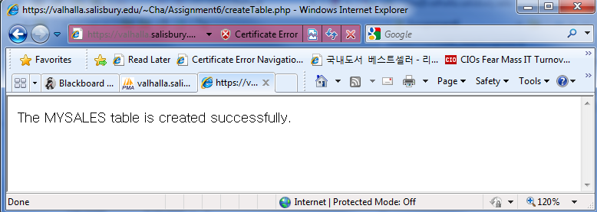

Screen captured:
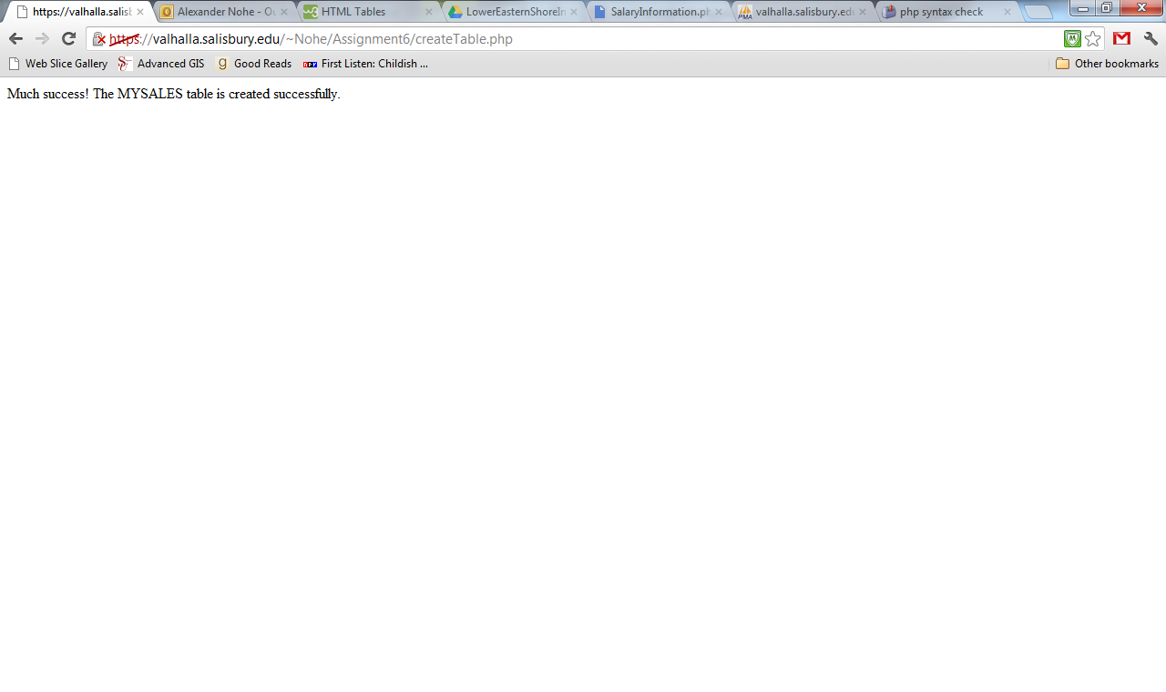

(4) Check your database and confirm that the SALES table was successfully created. Then, capture the screen output here similar to the example shown below. Make sure that it includes the database name and table name.
Example:

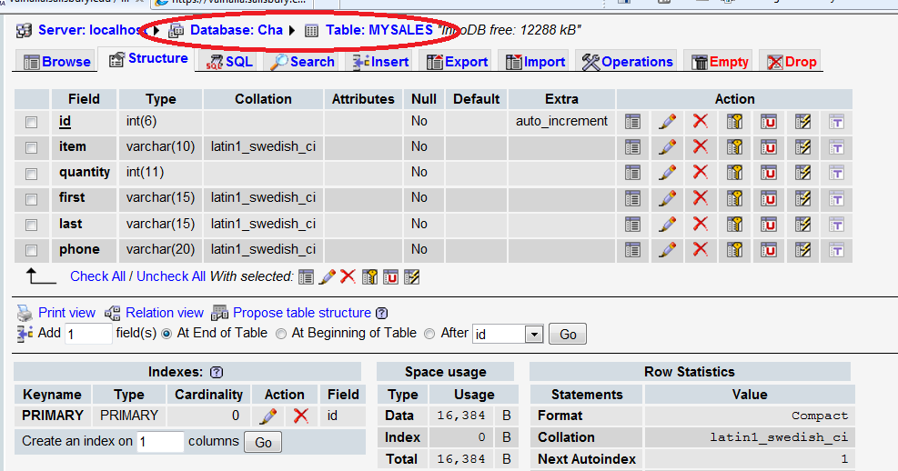

Screen captured:
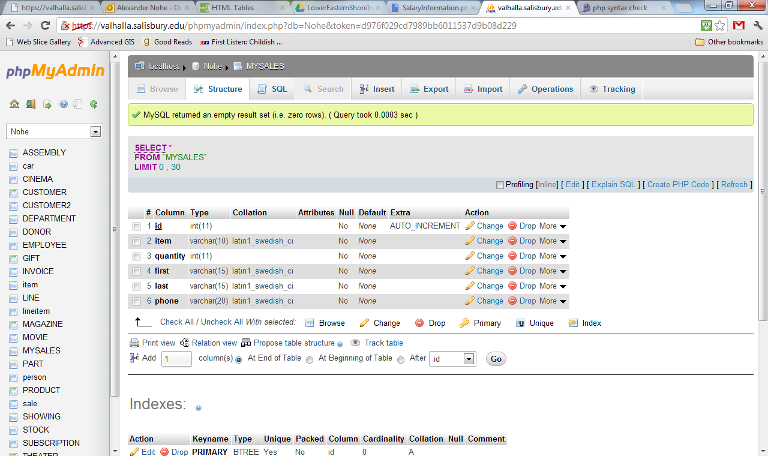

(30 points)
2. Create the order form.
We first create an HTML form that will let our customer choose what they would like to purchase. This file should be saved as "order.html"
(1) Complete the following html codes and save it as “order.html” in your Assignment6 directory. (You must replace the following code with your complete script in the hard copy of your assignment.)

<html>
<body>
<!--This is a comment. Comments are not displayed in the browser-->
<!—The font size is header 4-->
<h4>ABC Art Supply Order Form</h4>

<!—Starting form. You need to specify the action and method -->
<form action="process.php" method="POST">
<p> Item:
<!--This is the tag for the drop down list box.-->
<select name="item" id="item">
<option value="paint">Paint</option>
<option value="brushes">Brushes</option>
<option value="erasers">Erasers</option>
</select>
</p>
<p>Quantity:
<input name="qty" type="text" id="qty" />
</p>

<p>Customer Information</p>

<!--This is the tag for a table-->
<table width="50%" border="1">
<tr>
<td width="36%">First Name</td>
<td width="64%"><input name="fname" type="text" id="fname"></td>
</tr>
<tr>
<td>Last Name</td>
<td><input name="lname" type="text" id="lname"></td>
</tr>
<tr>
<td>Phone Number</td>
<td><input name="phone" type="text" id="phone"></td>
</tr>
</table>
<p>&nbsp;</p>
<p>
<input type="submit" />
</p>
</form>
<!—The form is closed-->
</body></html>

(2) Capture the screen output here similar to the example shown below.
Example:
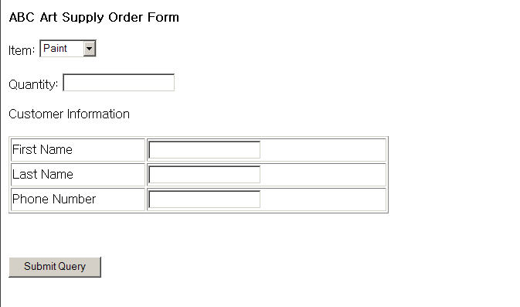

Screen captured:
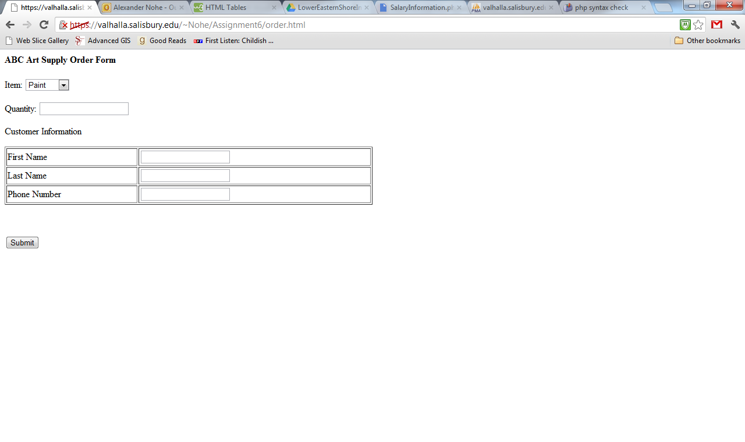

(40 points)
3. Processing the order: process.php
After a new order is submitted, you need to
- Save the information in the MYSQLES table, and then
- List all the sales order you have so far (including the new one just entered).

Complete the following php codes and save it as “process.php” in your Assignment6 directory. (You must replace the following code with your complete script in the hard copy of your assignment.)

<?php
// We need to include 'connect.php' here
include ('connection.php');

//Collet all the information passed from the previous order.html page using $_POST array variable.
$item= $_POST['item'];
$qty= $_POST['qty];
$fname= $_POST['fname'];
$lname= $_POST['lname'];
$phone= $_POST['phone'];

$query = "INSERT INTO `MYSALES`(`id`, `item`, `quantity`, `first`, `last`, `phone`) VALUES ('$id','$item','$quantity','$first','$last','$phone')";
$result=mysql_query($query);

if ($result){
//If the data is inserted successfully, we want to list up all the sales orders
//create a query string
$query = "SELECT * FROM MYSALES";

//get the result set
$result = mysql_query($query);

echo "<b><center>List of Sales Orders</center></b><br><br>";

//Start while statement here

while($row = mysql_fetch_array($result)){

?????

}//End while statement

}//End if statement
else
die ("Cannot create a new sales order");
mysql_close();
?>

(2) Capture the screen output here similar to the example shown below.

Example:
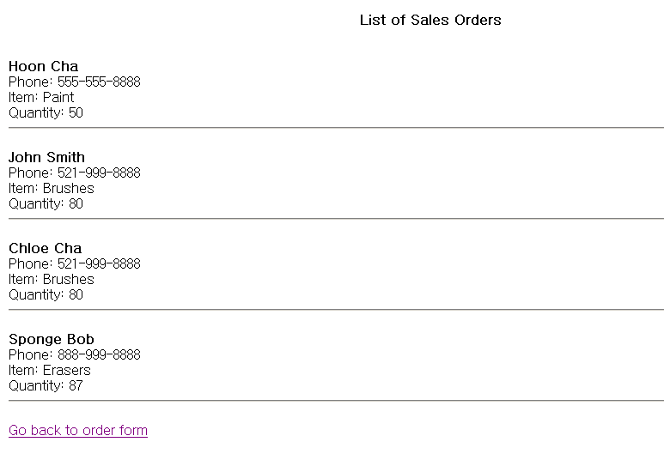

Screen captured:

